Analyze Kickstarter past projects

# Kickstarter campaigns conclusion

By analyze the data of 4000 projects for Kickstarter I found that the most successful category would be music as there is 700 projects in this field and 540 projects reached the funded stage. Theatre is the most represented category. Most of the projects is concentrated in these countries US, GB and CA. 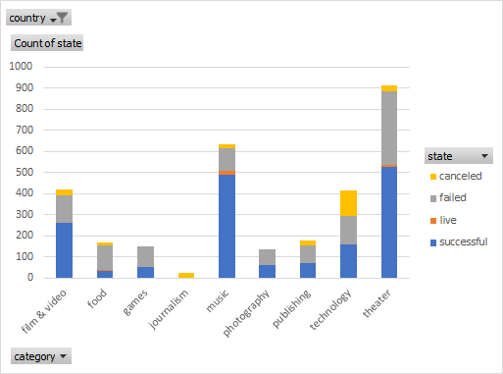

Classic music, documentary, hardware, nonfiction, metal, pop, radio & podcasts, rock, shorts, table top games and television are 100% successful projects.

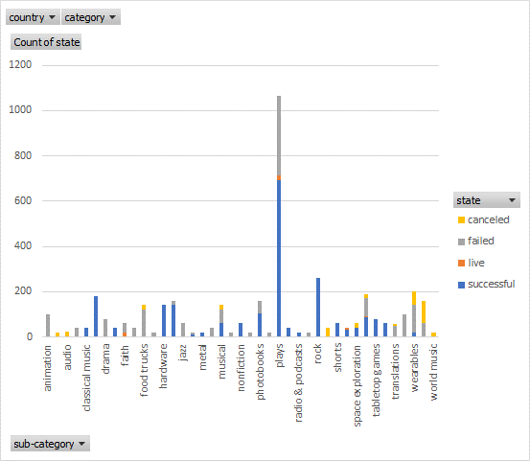

May is the month with the most successful number of project and December is the least.

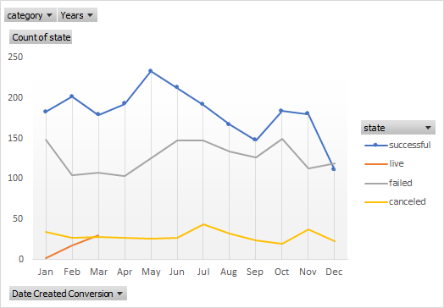

# limitations of this dataset

it is missing the data about the backers and the reasons why some of the project been cancelled.

# possible tables/graphs that we could create

we could create scatter plot to show the correlation between the goal and the pledged amount to see if it has positive or negative correlation.

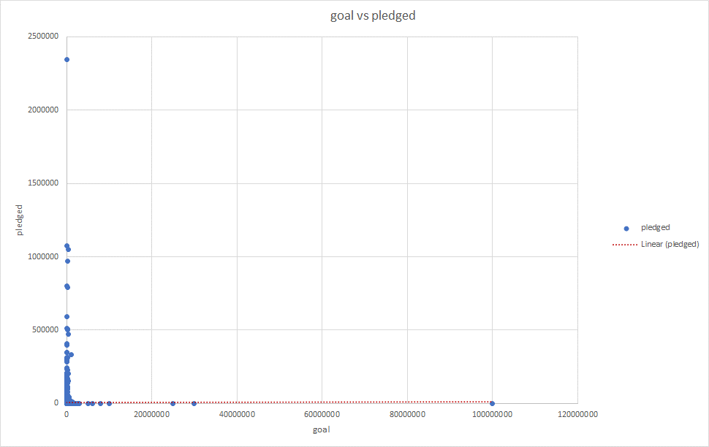

Pivot table and pivot pie chart to visualize the percentage of successful, cancelled, failed and live projects

